Parish Councillors are duly summoned to attend a Briercliffe with Extwistle Annual Parish Council meeting to be held Thursday February 13th 2025 at 7.30pm at the Community Centre, Jubilee Street

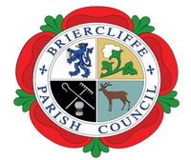

Members of the public are invited to attend.

BRIERCLIFFE WITH EXTWISTLE PARISH COUNCIL

EXTRAUDINARY PARISH COUNCIL MEETING

Thursday 13th February 2025 at 7.30pm

Welcome

1. Apologies for absence and reasons given

2. Declarations of Disclosable Pecuniary Interests

3 Finance – accounts to be approved for payment.

 [www.briercliffe-pc.gov.uk](http://www.briercliffe-pc.gov.uk/)